**A PRELIMENERY REPORT ON**

**EFFICIENT FARMER TO CONSUMER WEB APP**

SUBMITTED TO THE MUMBAI UNIVERSITY, MUMBAI

IN THE PARTIAL FULFILLMENT OF THE REQUIREMENTS

FOR THE AWARD OF THE DEGREE

OF

**BACHELOR OF ENGINEERING (INFORMATION TECHNOLOGY**)

SUBMITTED BY

|  |  |
| --- | --- |
| **MR. KADAM DARSHAN BALASAHEB** | **(UID 121IT3236A)** |
| **MR. NIPANE ARYAN SANJAY** | **(UID 120IT1228A)** |
| **MR. PAWAR HERSCHEL PRAVIN** | **(UID 120IT1108A)** |
| **MR. THORAT MANISH SANTOSH** | **(UID 120IT1006A)** |

Under the Guidance of

**Prof. Madhuri Patil**



**DEPARTMENT OF INFORMATION TECHNOLOGY**

**MGM’S COLLEGE OF ENGINEERING AND TECHNOLOGY,**

**NAVI MUMBAI, KAMOTHE- 410209**

**MUMBAI UNIVERSITY**

**A.Y. 2023-2024**



## **CERTIFICATE**

This is to certify that the Project report entitled

“**EFFICIENT FARMER TO CONSUMER WEB APP**”

SUBMITTED BY

|  |  |
| --- | --- |
| **MR. KADAM DARSHAN BALASAHEB** | **(UID 121IT3236A)** |
| **MR. NIPANE ARYAN SANJAY** | **(UID 120IT1228A)** |
| **MR. PAWAR HERSCHEL PRAVIN** | **(UID 120IT1108A)** |
| **MR. THORAT MANISH SANTOSH** | **(UID 120IT1006A)** |

is a bonafide student of this institute and the work has been carried out by him/her under the supervision of **Prof. Madhuri Patil** and it is approved for the partial fulfillment of the requirement of Mumbai University, for the award of the degree of **Bachelor of Engineering** (Information Technology).

|  |
| --- |
| **Prof. Madhuri Patil** |
| Guide |
| Department of Information Technology |

|  |  |
| --- | --- |
| **Dr. Swati Sinha** | **Dr. Geeta S. Lathkar** |
| Head | Director |
| Department of Information Technology | MGMCET, Navi Mumbai |

Place: Kamothe

Date:

## **PROJECT REPORT APPROVAL FOR B.E**

This Project entitled “**EFFICIENT FARMER TO CONSUMER WEB APP**” by **MR. KADAM DARSHAN BALASAHEB (UID 121IT3236A), MR. NIPANE ARYAN SANJAY (UID 120IT1228A), MR. PAWAR HERSCHEL PRAVIN (UID 120IT1108A), MR. THORAT MANISH SANTOSH (UID 120IT1006A)** is approved for the degree of Bachelor of Engineering in Information Technology.

.……………………………………

External Examiner

.……………………………………

Internal Examiner

Place: Kamothe

Date:

**DECLARATION**

We declare that this written submission represents our ideas in our own words and where other’s ideas or words have been included, we have adequately cited and referenced the original sources. We also declare that we have adhered to all principles of academic honesty and have not misrepresented or fabricated or falsified any idea/data/fact/source in our submission. We understand that any violation of the above will be cause for disciplinary action by the institute and can also evoke penal action from the source which has thus not been properly cited or from whom proper permission has not been taken when needed.

|  |  |  |  |
| --- | --- | --- | --- |
| Sr. No | Name of Student | UID | Signature |
| 1. | MR. KADAM DARSHAN BALASAHEB | UID 121IT3236A |  |
| 2. | MR. NIPANE ARYAN SANJAY | UID 120IT1228A |  |
| 3. | MR. PAWAR HERSCHEL PRAVIN | UID 120IT1108A |  |
| 4. | MR. THORAT MANISH SANTOSH | UID 120IT1006A |  |

Place: Kamothe

Date:

**ACKNOWLEDGEMENT**

The success and outcome of this project required a lot of guidance and assistance from many people and we are extremely fortunate to have got this all along with the completion of our project work. Whatever we have done is only due to such guidance and assistance and we would not forget to thank them. It is a matter of great pleasure for us to submit the project report on “**EFFICIENT FARMER TO CONSUMER WEB APP**” as a part of our curriculum.

First and foremost, we would like to thank our Director Dr. Geeta S. Lathkar, for giving us an opportunity to do the project work. We would like to thank our H.O.D and teachers for the valuable guidance and advice. To inspire us greatly to work on this project and willingness to motivate us contributed tremendously to our project.

And finally, a special thanks goes to my team members, who helped me to assemble the information and gave suggestions to complete our project.

|  |
| --- |
| MR. KADAM DARSHAN BALASAHEB |
| MR. NIPANE ARYAN SANJAY |
| MR. PAWAR HERSCHEL PRAVIN |
| MR. THORAT MANISH SANTOSH |

**ABSTRACT**

This paper introduces a MERN stack-based web platform designed to connect farmers, consumers, and sellers, with the primary aim of facilitating direct exchanges of agricultural products. The platform enables farmers to list and promote their produce, consumers to browse and purchase locally-sourced items, and sellers to market agricultural supplies. The MERN stack technology ensures scalability and responsiveness, offering a user-friendly interface for all participants.

The website's core objective is to eliminate intermediaries in the agricultural supply chain, fostering more efficient and transparent transactions. By promoting direct sales and reducing overhead, this platform empowers farmers, benefits consumers with access to fresh local products, and offers sellers a dedicated agricultural clientele. The potential impact includes a more sustainable, equitable food system and improved agricultural sustainability.

In summary, this paper presents a technology-driven solution to bridge the gap between farmers, consumers, and sellers in the agricultural market, offering a user-friendly and efficient platform to promote direct transactions and enhance the quality and sustainability of the agricultural supply chain.

# **TABLE OF CONTENTS**

|  |  |
| --- | --- |
| LIST OF FIGURES | i |

|  |  |  |
| --- | --- | --- |
| **Chapter** | **Title** | **Page No.** |
| Sr. No. | Title of Chapter | Page No. |
| **1** | **Introduction** | **1** |
| 1.1 | Purpose | **2** |
| 1.2 | Scope | **4** |
| **2** | **Literature Survey** | **5** |
| **3** | **Software Requirements Specifications** | **7** |
| **3.1** | **Introduction** | **7** |
|  | 3.1.1 Project Scope | **7** |
|  | 3.1.2 Assumptions and Dependencies | **7** |
| **3.2** | **Functional Requirements** | **9** |
| **3.3** | **Non-Functional Requirements** | **9** |
|  | 3.3.1 Performance Requirements | **9** |
|  | 3.3.2 Safety Requirements | **9** |
|  | 3.3.3 Security Requirements | **9** |
|  | 3.3.4 Software Quality Attributes | **9** |
| **4** | **Design & Implementation** | **10** |
| 4.1 | Software Analysis | **11** |
| 4.2 | Database ER-Diagram | **11** |
| 4.3 | Flowchart | **12** |
| **5** | **Conclusion and Future Works** | **18** |
| **6** | **References** | **19** |

**LIST OF FIGURES**

|  |  |  |
| --- | --- | --- |
| **Fig No** | **Title** | **Pg. No** |
| **1.1** | Database ER-Diagram | **8** |
| **1.2** | Flowchart | **9** |
| **1.3** | Flowchart cont. | **10** |
| **1.4** | Front Page | **11** |
| **1.5** | Products Page | **11** |
| **1.6** | Product Details Page | **12** |
| **1.7** | Cart Page | **13** |
| **1.8** | Address Input | **13** |
| **1.9** | Payment Methods | **14** |

# **CH**APTER **1**

## **INTRODUCTION**

The agricultural sector, a cornerstone of human civilization, is currently at the cusp of significant transformation, driven by the confluence of technology and evolving consumer preferences. In recent years, there has been a discernible shift in how agricultural products reach consumers. The traditional model, characterized by a convoluted and often inefficient supply chain with multiple intermediaries, is making way for a more direct, digitally-infused approach. This shift arises from the increasing demand for fresh, locally-sourced products and a growing awareness of the environmental and economic benefits associated with reduced supply chain complexity.

In response to these evolving demands, a novel web platform has emerged as a key player, leveraging the capabilities of the MERN stack (MongoDB, Express, React, Node.js). This platform is designed to address the critical challenge of bridging the gap between three integral players in the agricultural ecosystem: farmers, consumers, and sellers. By fostering direct interactions and transactions among these stakeholders, it aims to optimize the exchange of agricultural products while promoting transparency, trust, and sustainability within the sector.

The platform's central function is to provide an online marketplace where farmers can showcase their produce and connect directly with consumers. By doing so, it removes the need for intermediaries, thus streamlining the agricultural supply chain. This approach has far-reaching implications, not only in terms of boosting the economic prospects of farmers but also in granting consumers access to a wide range of fresh, locally-sourced agricultural products. Furthermore, the platform extends its reach to sellers, who offer an assortment of essential agricultural supplies, including seeds, equipment, livestock, and dairy products.

Within the context of this paradigm shift, the MERN stack, comprising MongoDB, Express, React, and Node.js, emerges as a technological bedrock that underpins the platform's robust functionality. MongoDB, as a database system, facilitates the efficient storage and management of diverse data associated with agricultural products and transactions. Express and Node.js provide the necessary server-side framework, while React offers an intuitive and responsive user interface, ensuring the scalability and adaptability required to accommodate the dynamic and multifaceted agricultural market.

This paper dives into the development and implications of this innovative web platform, offering a comprehensive understanding of how technology can reshape and revitalize the agricultural sector. The aim is not just to connect farmers with consumers, but also to empower agricultural suppliers and promote an efficient, transparent, and sustainable food supply chain. As we delve deeper into the nuances of this transformative endeavor, it becomes evident that the platform has the potential to drive the growth of the agricultural sector, improve access to high-quality, locally-sourced agricultural products, and bolster the sustainability of the agricultural ecosystem as a whole.

### 1.1 PURPOSE

The primary purpose of this research paper is to comprehensively explore and elucidate the development and potential impact of an innovative web platform designed to facilitate direct interactions and transactions among farmers, consumers, and sellers within the agricultural ecosystem. This purpose can be further broken down into the following specific objectives:

1. Platform Development: To provide an in-depth understanding of the technical underpinnings of the web platform, with a particular focus on the use of the MERN stack, including MongoDB, Express, React, and Node.js, and its role in enabling a user-friendly interface for all participants.
2. Stakeholder Engagement: To examine the distinct roles and interactions of the three primary stakeholders - farmers, consumers, and sellers - within the platform, showcasing how it enables each of them to benefit from a more direct and efficient agricultural market.
3. Supply Chain Streamlining: To highlight the role of the platform in reducing intermediaries and streamlining the agricultural supply chain, ultimately resulting in more efficient and transparent transactions.
4. Economic Empowerment: To assess the economic implications of the platform, specifically how it empowers farmers by allowing them to reach a broader consumer base, potentially increasing their income and profitability.
5. Consumer Access: To investigate how the platform benefits consumers by providing them with access to fresh, locally-sourced agricultural products, promoting the consumption of healthier and more sustainable food choices.
6. Sustainability and Transparency: To underscore the potential impact of the platform in fostering greater sustainability and transparency within the agricultural sector, with a focus on promoting environmentally conscious agricultural practices.
7. Supplier Support: To shed light on how the platform accommodates agricultural suppliers, who play a crucial role in ensuring farmers have access to the necessary tools, equipment, and resources for a thriving agricultural enterprise.

### 1.2 SCOPE

This research paper focuses on a multifaceted exploration of an innovative web platform connecting farmers, consumers, and sellers in the agricultural sector. The scope includes:

1. Technical Aspects:

In-depth analysis of the MERN stack's role in platform development.

Examination of the platform's technical architecture and user interface.

1. Stakeholder Dynamics:

Understanding the roles and interactions of farmers, consumers, and sellers.

Exploring how the platform facilitates direct connections and transactions.

1. Supply Chain Optimization:

Investigation into the platform's contribution to streamlining the agricultural supply chain.

Analysis of its impact on transaction efficiency and transparency.

1. Economic Empowerment and Consumer Benefits:

Assessing the financial benefits for farmers and enhanced consumer access to local products.

Emphasizing the potential influence on consumption choices and sustainable farming practices.

1. Sustainability and Transparency:

Discussion of the platform's role in promoting sustainability and transparency in agriculture.

Highlighting its impact on environmentally conscious practices and supply chain transparency.

1. Supplier Engagement:

Insight into how the platform supports agricultural suppliers.

Ensuring resources for farmers and a dedicated agricultural clientele.

1. Future Implications and Limitations:

Consideration of scalability and broader industry impact.

Identification of potential limitations and challenges in platform implementation.

# CHAPTER 2

## **LITERATURE SURVEY**

* 1. **Digital Market: E-Commerce Application For Farmers**:

By: Mamata Khatu, Neethu Kaimal, Pratik Jadhav and Syedali Adnan Rizvi

The concept of a "digital market" represents a transformative platform in India that aims to connect farmers, merchants, government authorities, and end-users, bridging gaps between these key stakeholders. Indian farmers face various challenges, including limitations due to seasons and the short lifespan of crops. This platform provides real-time market information, empowering farmers to make informed decisions. Traditionally, farmers faced difficulties reaching merchants physically, limiting their options for selling their products. Furthermore, the lack of transparency in government-regulated minimum crop prices has been a concern.

The platform leverages technology, including mobile-based Android apps for farmers, users, and merchants, alongside web-based Java applications for government access. It utilizes algorithms like KNN for decision-making and Haversine for GPS-based location verification during transactions. The government can set rules and minimum prices, resolve complaints, and manage price fluctuations using data-driven techniques.

Despite its benefits, one challenge is tracking transportation records in real-time. In summary, this digital market platform addresses critical issues in India's agricultural sector, promoting transparency and empowering farmers to access a broader client base and make more informed decisions.

# CHAPTER 2

## **LITERATURE SURVEY**

**2.2 Research on Influencing Factors of Retail Sales in E-Commerce Market**

By: Jiao Qidi

The paper investigates factors influencing retail sales in China's e-commerce market, focusing on urban and rural residents' consumption expenditure. Through multiple linear regression analysis, it finds that urban and rural consumption expenditures significantly impact e-commerce retail sales, with rural spending exhibiting a positive influence.

# CHAPTER 2

**LITERATURE SURVEY**

**2.3 MongoDB scheme analysis**:

By: Liberies Vokorokos, Matúš Uchnár, Anton Baláž

The paper aims to create a web administration interface for analyzing data stored in MongoDB databases. It discusses the design of a tool comprising a console application for analysis and a web application for visualization, highlighting its speed, features, and testing.

# **3. SOFTWARE REQUIREMENT ANALYSIS**

## **3.1 INTRODUCTION**

### **3.1.1 PROJECT SCOPE**

This research paper presents a comprehensive examination of an innovative web platform that connects farmers, consumers, and sellers in the agricultural sector. It covers technical aspects, focusing on the MERN stack's role in platform development and the intricate technical architecture and user interface. The paper also explores stakeholder dynamics and the platform's contribution to supply chain optimization, emphasizing economic empowerment for farmers and benefits for consumers, including sustainable farming practices. Additionally, it highlights the platform's role in promoting sustainability and transparency in the agricultural sector and supporting agricultural suppliers. The paper concludes by considering the platform's future implications and potential limitations, including scalability and its broader impact on the agricultural industry.

### 3.1.2 ASSUMPTIONS AND DEPENDENCIES

**ASSUMPTIONS:**

1. Assumption of Technological Readiness: The project assumes that the technological infrastructure and resources required for implementing the web platform, including the availability and proficiency of the MERN stack, are readily accessible and viable for deployment.
2. Assumption of Stakeholder Willingness: It assumes that farmers, consumers, and sellers are willing to adopt and engage with the platform, recognizing the benefits it offers in terms of direct interactions and transactions.
3. Assumption of Data Accuracy: The project assumes that the data related to agricultural products, transactions, and stakeholder interactions are accurate and reliable, as this data forms the foundation for the platform's functionality.
4. Assumption of Economic Impact: There is an assumption that the platform will indeed lead to economic empowerment for farmers, increased consumer access to local products, and a shift towards more sustainable farming practices, even though these outcomes might depend on various factors beyond the platform itself.
5. Assumption of Environmental Impact: The project assumes that the adoption of the platform will lead to improved environmental sustainability in agriculture, although this is contingent on the actual practices and choices of farmers and consumers.
6. Assumption of Supplier Engagement: It assumes that agricultural suppliers will actively engage with the platform to support farmers and provide essential resources, as their involvement is crucial for the platform's success.
7. Assumption of Scalability: The project assumes that the platform can be scaled up effectively to accommodate a larger user base and have a significant impact on the broader agricultural industry.
8. Assumption of User Interface Suitability: It assumes that the user interface provided by the platform, built with React, is user-friendly and capable of meeting the diverse needs of farmers, consumers, and sellers.

**DEPENDENCIES**

1. Technical Infrastructure: The availability and reliability of the technical infrastructure required for the platform, including server hosting, internet connectivity, and hardware, are critical dependencies.
2. MERN Stack: The project relies on the MERN stack, which includes MongoDB, Express, React, and Node.js. Dependencies on the stability and compatibility of these technologies are essential.
3. Data Sources: The accuracy and availability of data related to agricultural products, transactions, and stakeholder information are crucial. This data can come from various sources and should be dependable.
4. User Adoption: The success of the platform depends on the willingness of farmers, consumers, and sellers to adopt and actively engage with it. User buy-in is a significant dependency.
5. Supplier Engagement: The involvement of agricultural suppliers in providing resources and support to farmers is necessary for the platform's functionality and success.
6. Regulatory Compliance: The project may be subject to regulatory and legal requirements related to data privacy, e-commerce, and agricultural practices. Compliance with these regulations is a critical dependency.
7. Funding and Resources: The availability of funding and resources for platform development, maintenance, and scaling is a significant dependency. Financial and human resources are essential for project success.
8. Scalability: The platform's ability to scale and accommodate a growing user base is a dependency, as it needs to handle increased traffic and data.
9. Environmental Factors: The success of sustainability and environmentally conscious practices may depend on factors such as weather conditions, local ecosystems, and the willingness of farmers to adopt sustainable practices.
10. Consumer Behavior: The impact of the platform on consumer behavior and choices is a dependency. It relies on consumers opting for locally-sourced and sustainable agricultural products.
11. Competitive Landscape: The project's success could be influenced by the presence of competing platforms or initiatives in the same agricultural market.
12. Technological Updates: The MERN stack and other technologies used in the platform may undergo updates and changes, which could impact the platform's functionality and compatibility.
13. Market Trends: The project depends on an understanding of evolving consumer preferences and market trends in the agricultural sector, as these factors may influence the platform's design and features.

## **3.2 FUNCTIONAL REQUIREMENTS**

1. User Registration and Profiles:

Users can register accounts with basic profile information, including user type (farmer, consumer, or seller).

1. Product Listings:

Farmers can create, update, and delete listings for their agricultural products, including product name, description, quantity, and price.

Consumers and sellers can browse and search for products.

1. Transaction Management:

Users can initiate and manage transactions for agricultural products.

The platform supports secure payment processing.

1. User Management and Security:

User accounts and data are securely managed.

User authentication, including password reset and account recovery, is available.

### 3.3.1 PERFORMANCE REQUIREMENT

* Better User Experience: The MERN stack, with React, makes websites more enjoyable to use.
* Faster Data Transfer: The MERN stack can send and receive data quickly, so web pages load fast.
* Quick Server Responses: The MERN stack's server part, Node.js, responds to requests without making users wait.
* Saved Web Pages: MERN can save web pages on your computer so they load faster the next time you visit.
* Smart Memory Usage: MERN manages memory well, making sure it doesn't keep old stuff, so it works efficiently.

### **3.3.2 SAFETY REQUIREMENT**

* User Safety: Using the system should not harm people in any way.
* Protection from the Internet: The system should be able to defend itself against threats from the outside internet.

### **3.3.3 SECURITY REQUIREMENTS**

* Data Security: The system must ensure that data is kept secure. Regular users will have read-only access and won't be able to edit or modify their personal and specific information.
* User Access Control: The system will support various types of users, each with specific access constraints and permissions.

### **3.3.4 SOFTWARE QUALITY ATTRIBUTES**

* Availability:

It is available 24 Hours worldwide across the globe on any web enabled device

that has internet connection.

* Portability:

It is portable since it is a web application and can be accessed from any browser.

## **3.4 SYSTEM REQUIREMENT**

### **3.4.1 SOFTWARE REQUIREMENTS**

Web browser enabled device with a camera

### **3.4.2 HARDWARE SPECIFICATION**

Hardware required: any web browser supported device with internet connection

# CHAPTER 3

## **DESIGN & IMPLEMENTATION**

### WORKING

The project is built using the MERN stack, which stands for MongoDB, Express, React, and Node.js, each playing a crucial role in making the system efficient and user-friendly. MongoDB serves as the database, where all the data about the products, farmers, and consumers is stored. Express and Node.js work on the server-side, handling requests and making sure data gets to the right places. React, on the other hand, provides a user-friendly interface, making it easy for farmers to list their products and for consumers to browse and buy.

Behind the scenes, REST API (Representational State Transfer Application Programming Interface) is used to facilitate communication between the different parts of the project. It ensures that when a farmer lists a product, that information gets to the database and is then presented to consumers in a user-friendly way. It also helps with secure payments when a consumer buys a product.

So, in simple terms, the project uses a special set of tools to make sure that when a farmer wants to sell something, it gets listed properly and is easy for people to buy. All this happens safely and efficiently with the help of REST API, and the data is kept in a big digital storage (MongoDB). This way, the project brings farmers and consumers closer, making transactions smoother and more transparent.

## ARCHITECTURE

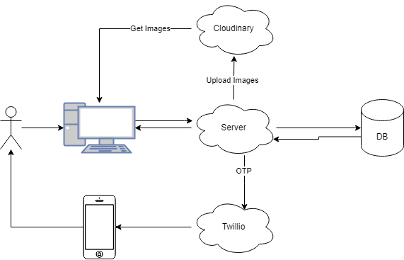

* User: Users perform actions such as accessing services and submitting requests.
* PC: Serves as the interface through which users interact with the system. Users initiate actions on their web browser, which are then processed by the server.
* Phone: Used for logging into the system via one time password (OTP)
* Server: Acts as an intermediary between the user and various backend services. It receives requests from the PC, processes them, and interacts with other components to fulfill the requested actions.
* Database (DB): Stores and manages structured data related to products, user registrations, and equipment. The server communicates with the database to perform operations such as adding and retrieving data.
* Twilio: The server interacts with Twilio's API to send one-time passwords (OTPs) to users' phones for authentication or verification purposes.
* Cloudinary: The server interacts with Cloudinary to upload and manage visual content such as product images.

## DATABASE ER-DIAGRAM

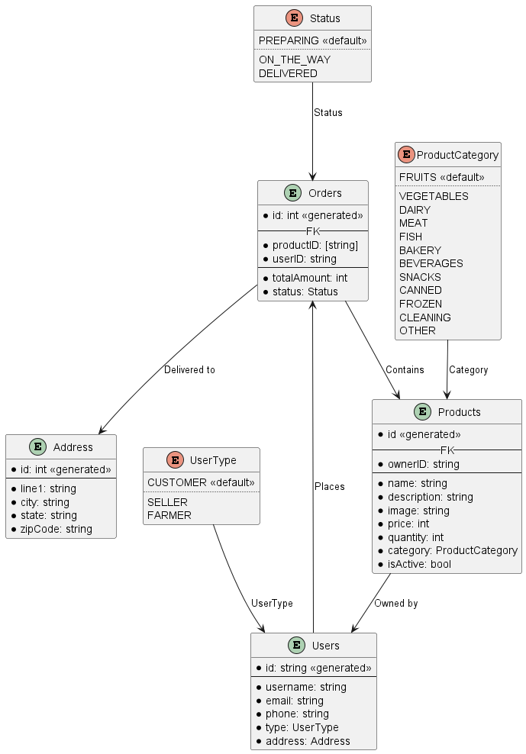

## USECASE

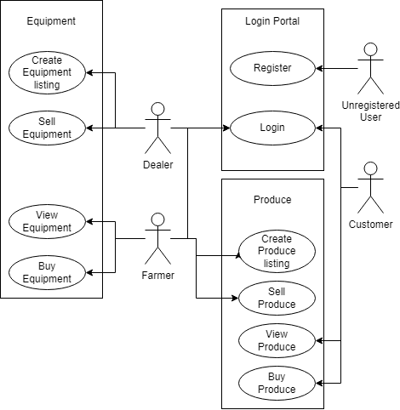

The use case diagram depicts the interactions between various actors and the system for a farming market webapp. The actors involved in the system are:

* Farmer: A user who produces crops or other agricultural products.
* Dealer: A user who sells farming equipment, seeds, fertilizer, pesticides, etc to the farmer.
* Customer: A user who buys produce directly from farmers.
* Unregistered User: A potential user who has not yet registered with the platform.

The main functionalities of the system include:

* Register: Unregistered users can register to become members of the platform.
* Login: Farmers, dealers, and customers need to log in to access the platform.
* View and Buy Produce: Customers can view and purchase produce from farmers.
* View and Buy Equipment: Farmers can view and purchase available equipment.
* Create and Sell Produce/Equipment: Farmers can list their produce for sale, and dealers can list their equipment for sale.

## DATA FLOW

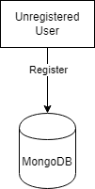

An unregistered user can only register to the system and thus the data only flows from them to the MongoDB instance.

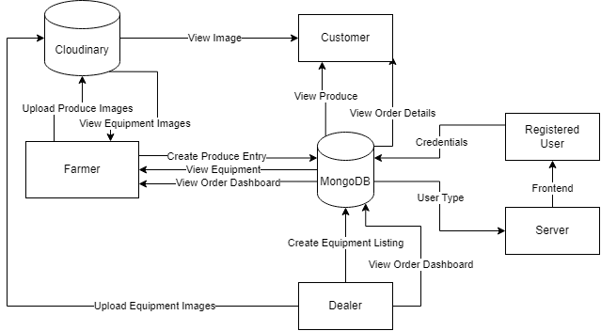

1. MongoDB
   * Represents the database system.
   * Plays a central role in the system since majority of the data is stored in the database
2. Cloudinary (Cloud Storage)
   * Stores the images uploaded by farmers (for produce) and dealers (for equipment)
   * The images are then viewed by farmers (for equipment) and customers (for produce)
3. Twillio (SMS Service)
   * Sends the OTP to the user for logging into the system

A registered user will enter their credentials and the server will check the credentials in the database, the database responds if the credentials are valid and what their role is. The server then proceeds to show the appropriate pages to the user.

# System Implementation

## Screenshots

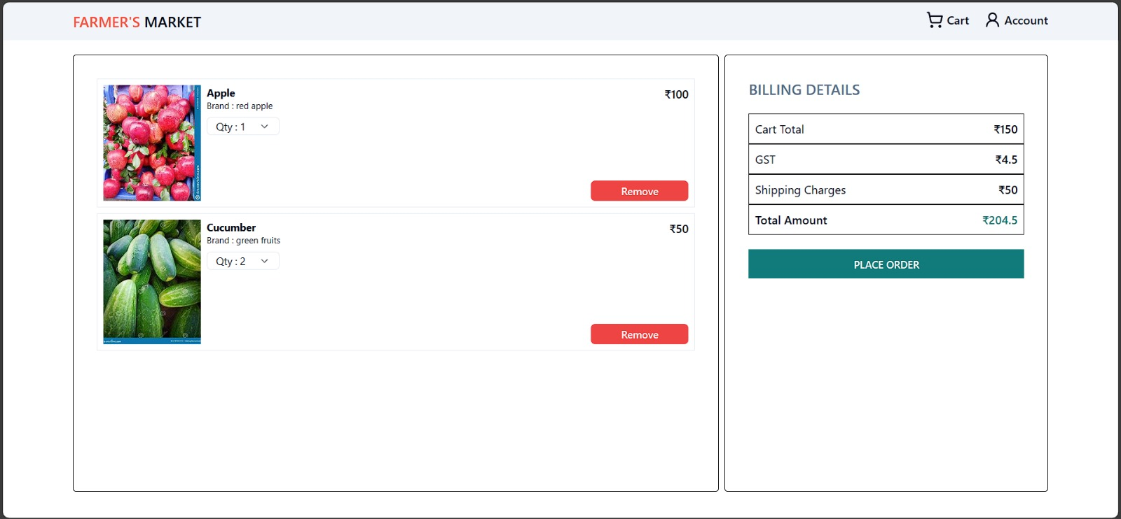

**Image 1:** Order Cart Page

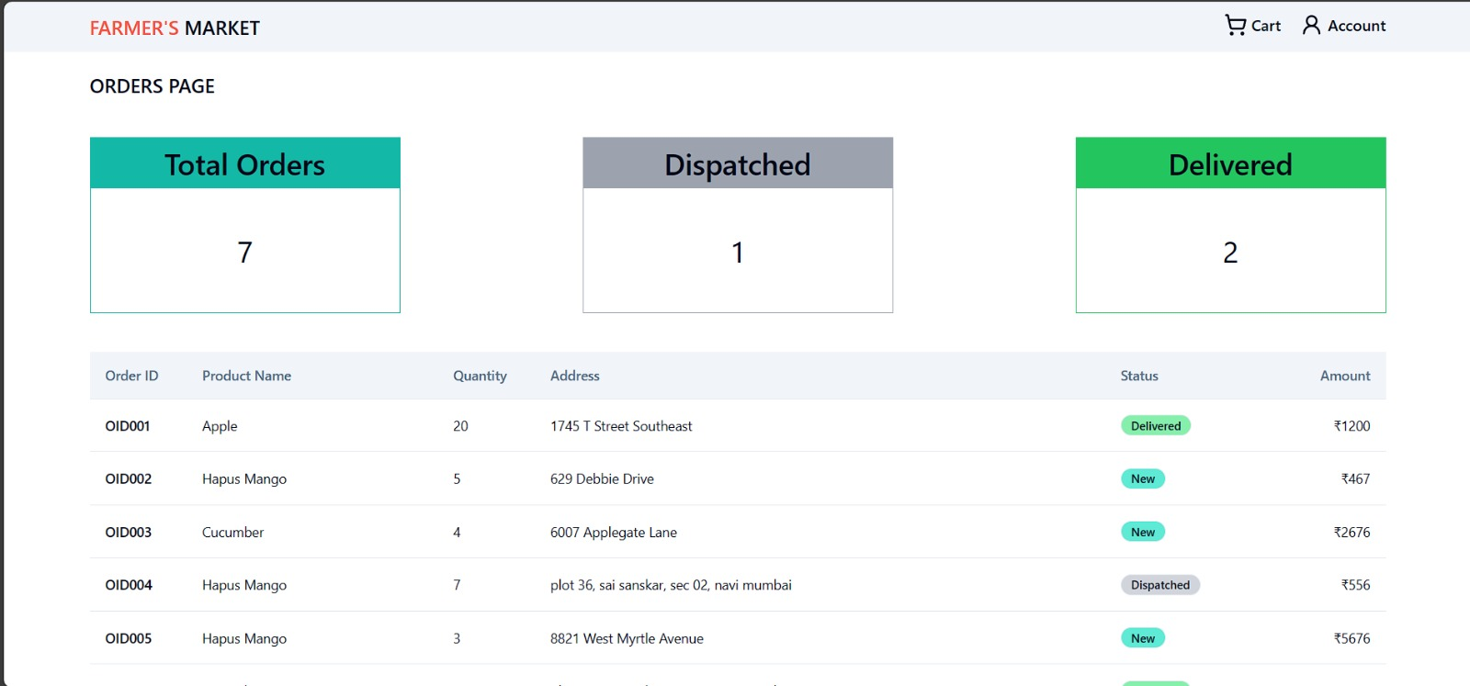

**Image 2:** Farmer Orders Dashboard

**Image 3:** Browsing Products from Dealer

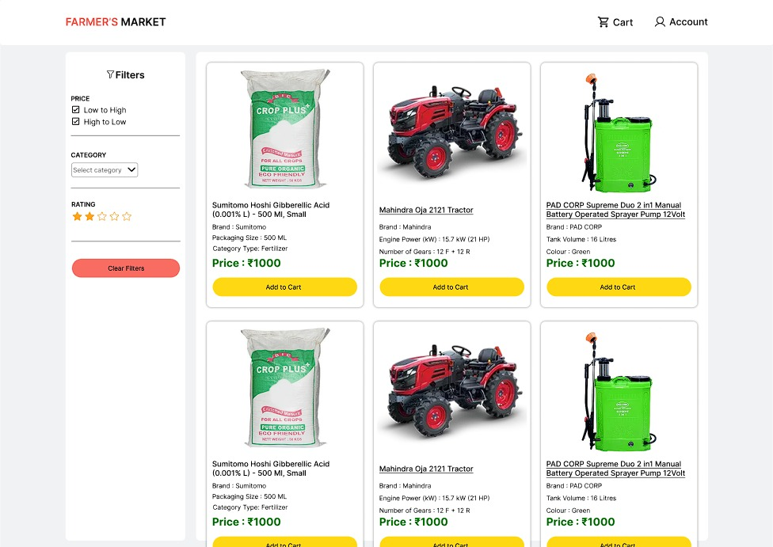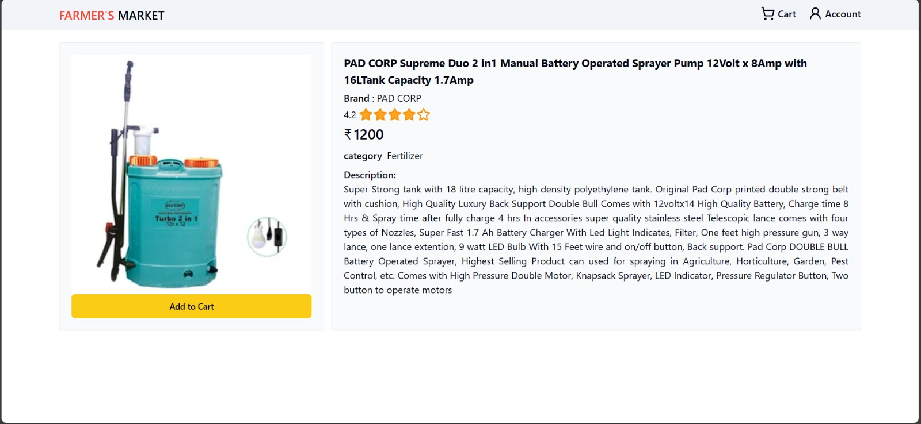

**Image 4:** Product Page

## Advantages

### Enhanced User Experience

By providing functionalities for farmers, dealers, and customers, the platform caters to a diverse user base, offering convenience and accessibility for various stakeholders in the farming market.

### Efficient Data Management

MongoDB's flexibility and scalability allow for efficient storage and management of structured data related to products, user registrations, and equipment, ensuring smooth operations even as the platform grows.

### Secure Authentication

Integrating Twilio for sending OTPs enhances security by adding an extra layer of authentication, ensuring that only authorized users can access the system, thus safeguarding sensitive information.

### Visual Content Management

Utilizing Cloudinary for storing and managing visual content such as product images enhances the presentation of products, making the platform more visually appealing and engaging for users.

### Scalability

The architecture's modular design allows for scalability, enabling the platform to accommodate a growing user base and increasing data volume without significant disruptions or performance issues.

## Limitations:

### Dependency on External Services

Relying on external services like Twilio and Cloudinary introduces dependencies that can affect system availability and performance if these services experience downtime or disruptions.

### User Adoption Challenges

Encouraging unregistered users to register and engage with the platform may pose challenges, requiring effective marketing and user onboarding strategies to drive adoption and participation.

### Integration Complexity

Integrating multiple components such as MongoDB, Twilio, and Cloudinary requires careful planning and implementation to ensure seamless communication and interoperability between different parts of the system.

### Maintenance Overhead

Managing and maintaining the system, including software updates, monitoring, and troubleshooting, can incur overhead in terms of time and resources, particularly as the platform scales and evolves over time.

## Applications

### Online Farming Marketplace

The platform serves as an online marketplace connecting farmers, dealers, and customers, facilitating the buying and selling of agricultural products and equipment.

### E-commerce for Agricultural Products

Customers can conveniently purchase fresh produce directly from farmers, promoting local agriculture and supporting small-scale farmers.

### Equipment Trading Platform

Farmers and dealers can trade agricultural equipment and supplies, expanding market reach and facilitating efficient exchange of farming resources.

### Community Engagement Platform

The platform can also serve as a community hub, enabling farmers to share knowledge, exchange experiences, and collaborate on agricultural initiatives, fostering a sense of community among users.

### Data Analytics and Insights

By collecting and analyzing data on user interactions, product sales, and market trends, the platform can provide valuable insights to stakeholders, enabling informed decision-making and strategy development in the farming industry.

# **System Testing**

## 6.1 Test Cases

### API Testing

|  |  |  |  |  |
| --- | --- | --- | --- | --- |
| SR NO | NAME | METHOD | ROUTE | NO OF ASSERTIONS |
| 1 | initiate farmer login | POST | api/send-otp | 6 |
| 2 | complete farmer login | POST | api/verify-otp | 18 |
| 3 | refresh | GET | api/refresh | 8 |
| 4 | create a product | POST | api/product | 8 |
| 5 | delete a product | DELETE | api/product-delete/:pid | 7 |
| 6 | get all products for the current farmer | GET | api/get-user-product | 4 |
| 7 | get product by id | GET | api/get-product/:pid | 50 |
| 8 | update product | POST | api/product-update/:pid | 7 |
| 9 | make product inactive | PUT | api/:pid/active | 2 |
| 10 | make product active | PUT | api/:pid/active | 2 |
| 11 | logout farmer | POST | api/logout | 7 |
| 12 | initiate customer login | POST | api/send-otp | 6 |
| 13 | complete customer login | POST | api/verify-otp | 18 |
| 14 | get all products | GET | api/get-product | 11 |
| 15 | add product to cart | POST | api/addToCart/:pid | 7 |
| 16 | get cart | GET | api/getUserCart | 5 |
| 17 | update cart product quantity | PUT | api/updateUserCart/:pid | 9 |
| 18 | delete product from cart | DELETE | api/deleteProductCart/:pid | 1 |
| 19 | create order | POST | api/order | 29 |

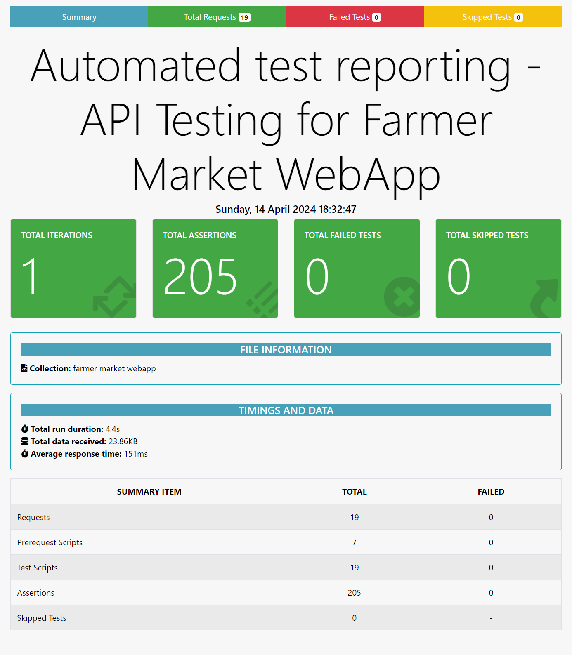

### Performance Testing

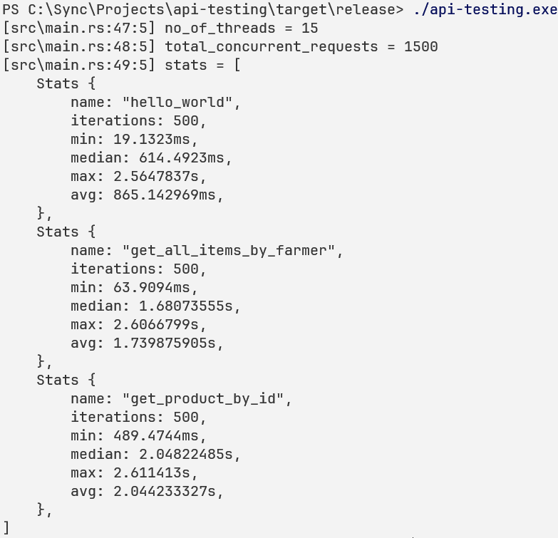

# **Result and Analysis**

The described architecture outlines a comprehensive system for a farming market web application, catering to farmers, dealers, and customers. It incorporates essential functionalities such as user registration, authentication, product listing, and purchasing, along with integrations with external services like Twilio for OTP authentication and Cloudinary for image storage. MongoDB serves as the central database, storing crucial data related to users, products, and transactions.

# Conclusions & Future Scope

Farmers Market WebApp presents a comprehensive framework for connecting farmers, dealers, and customers, facilitating transactions, and fostering community engagement in the agricultural sector. By integrating essential functionalities such as user registration, authentication, product listing, and purchasing, along with external services like Twilio for OTP authentication and Cloudinary for image storage, the platform aims to provide a seamless and secure user experience.

However, successful implementation and adoption of the platform will require careful consideration of security measures, scalability requirements, and user interface design, along with proactive maintenance and ongoing enhancements to meet evolving user needs and market dynamics. By leveraging data analytics and community building initiatives, the platform has the potential to drive innovation, collaboration, and growth in the farming market ecosystem.

## Future Scope

* Scaling the platform to target new geographical regions or niche markets, such as organic farming, or farm-to-table initiatives, can unlock opportunities for growth and diversification.
* Forming partnerships with agricultural organizations, research institutions, and government agencies can facilitate knowledge sharing, market access, and regulatory compliance, strengthening the platform's ecosystem and value proposition.
* Implementing machine learning algorithms and personalized recommendation systems can enhance user engagement by offering tailored product recommendations and content based on user preferences and behavior.
* Integrating with supply chain management systems and logistics providers can streamline product sourcing, inventory management, and order fulfillment processes, improving efficiency and transparency in the agricultural supply chain.
* Leveraging Internet of Things (IoT) technology for monitoring crop conditions, equipment performance, and environmental factors can enable predictive analytics and proactive decision-making, enhancing productivity and resource efficiency in farming operations.
* Exploring blockchain technology for secure and transparent transactions, traceability, and provenance verification can enhance trust and accountability in the agricultural marketplace, particularly for organic and sustainable products.

# References

1. S. Tilkov and S. Vinoski, “Node.js: Using JavaScript to Build High-Performance Network Programs”, IEEE Internet Computing, vol. 14, no. 6, pp. 80–83, Nov. 2010, doi: 10.1109/MIC.2010.145.
2. K. Saundariya, M. Abirami, K. R. Senthil, D. Prabakaran, B. Srimathi, and G. Nagarajan, “Webapp Service for Booking Handyman Using Mongodb, Express JS, React JS, Node JS”, in 2021 3rd International Conference on Signal Processing and Communication (ICPSC), May 2021, pp. 180–183. doi: 10.1109/ICSPC51351.2021.9451783.
3. Cloudflare, Inc., “How can serverless computing improve performance? | Lambda performance”, 2024, [Online]. Available: <https://www.cloudflare.com/ learning/serverless/serverless-performance/>
4. P. Castro, V. Ishakian, V. Muthusamy, and A. Slominski, “The rise of serverless computing”, Commun. ACM, vol. 62, no. 12, p. 44, Nov. 2019, doi: 10.1145/3368454.
5. Bhende, Manisha and Avatade, Mohini S. and Patil, Suvarna and Mishra, Pooja and Prasad, Pooja and Shewalkar, Shubham, “Digital Market: E-Commerce Application For Farmers”, 2018 Fourth International Conference on Computing Communication Control and Automation (ICCUBEA), pp. 1-7, Aug. 2018, doi: 10.1109/ICCUBEA.2018.8697615.
6. Y. Pei, W. Xue, Y. Su, and D. Li, "Discussion on influence factors and evaluation of customer experience for B2C E-commerce enterprises," in 2015 International Conference on Logistics, Informatics and Service Sciences (LISS), July 2015, pp. 1–5. doi: 10.1109/LISS.2015.7369651.
7. J. Qidi, "Research on Influencing Factors of Retail Sales in E-Commerce Market," in 2021 2nd International Conference on E-Commerce and Internet Technology (ECIT), March 2021, pp. 16–19. doi: 10.1109/ECIT52743.2021.00011.
8. W. Ma and D. Liu, "Research on E-commerce Development of Small and Medium-sized Enterprises Under the Background of Internet +," in 2021 2nd International Conference on E-Commerce and Internet Technology (ECIT), March 2021, pp. 181–184. doi: 10.1109/ECIT52743.2021.00048.
9. J. Huijing, Y. Xuefeng, P. Wenxue, G. Longwei, F. Linfeng, S. Yongbo, and W. ping, "Practical Exploration of Rural E-commerce Boosting Rural Revitalization Based on 4C Model," in 2021 2nd International Conference on E-Commerce and Internet Technology (ECIT), March 2021, pp. 74–78. doi: 10.1109/ECIT52743.2021.00023.
10. M. Rao, A. Singh, N. V. Subba Reddy, and D. Acharya, "Crop prediction using machine learning," Journal of Physics: Conference Series, vol. 2161, Jan. 2022, p. 012033. doi: 10.1088/1742-6596/2161/1/012033.
11. A. Motwani, P. Patil, V. Nagaria, S. Verma, and S. Ghane, "Soil Analysis and Crop Recommendation using Machine Learning," in 2022 International Conference for Advancement in Technology (ICONAT), Jan. 2022, pp. 1–7. doi: 10.1109/ICONAT53423.2022.9725901.
12. L. Vokorokos, M. Uchnár, and A. Baláž, "MongoDB scheme analysis," in 2017 IEEE 21st International Conference on Intelligent Engineering Systems (INES), Oct. 2017, pp. 67–70. doi: 10.1109/INES.2017.8118530.
13. B. Nguyen, "Improving Web Development Process of MERN Stack," Bachelor's Thesis, Metropolia University of Applied Sciences, May 2021, pp. 52. Available: <https://www.theseus.fi/handle/10024/498420> .
14. M. Gadhavi, "Full-Stack vs MEAN Stack vs MERN Stack: The Right Technology Stack for You in 2024," Radixweb, Dec. 18, 2023. [Online]. Available: <https://radixweb.com/blog/full-stack-vs-mean-stack-vs-mern-stack-development> .